**GDD of Castle Maze:-**

**Title:-** Castle Maze[*Its name was MazeRaider when I created the project first, then I changed it]

**High Pitch Line:-** Escape the Ancient Castle’s Mazes.

**Genre:-** 3D Puzzle

**Orientation:-** Landscape

**Platform:-** PC(in future maybe for Android)

**Target Audience:-** 15 to 24 years old

**Long Description:-**

You are an explorer, who is trapped into an ancient castle’s dungeon which is basically a maze. The only thing you have is a torch in your hand. Your only goal is to find your way out of the dungeon maze. The dungeon has many locked doors which can only be open by specific keys. The more you get into the maze it will become more complex and there will be some traps that can kill you instantly. So, look out for the traps and try to avoid them. There are some levers that can turn off those traps so you better find them to advanced further. ~~There is a map for the maze room that can help you to find your way out but it can’t be picked up, you have to memorize it. The map is not easy to find. The map will be only in the complex maze rooms.~~

**Game Mechanics:-**

Movement: Move the character with basic movement keys (W A S D), move the camera with the help of mouse. To jump press ‘space’ key.

Interaction: There are certain intractable objects like Door, Trap and Lever. In case of Traps the player will be eliminated instantly. To avoid that the player has to find that lever that tours off the trap. To open a specific door the player has to find a specific key. The key can be picked up by pressing the key ‘E’.

Obstacles: There are some traps that can’t be disabled by any lever, it can only be avoided. Player has to be careful because these traps are very much hidden.

~~Maps: The maps are the best things for the player but it can be found rarely. The map can’t be picked up it can only be seen at a very specific place. Player has to remember the way out. Be careful, the traps are not shown on the map.~~

**Menu Flow:-**

1. Home -> [1. Play, 2. Settings, 3. Exit, 4. About the Game]
2. Play -> [1.Choose Level, 2.Home]
3. Settings -> [1. Sound, 2. Graphics, 3. Home]
4. Choose Level -> [1.Game Play Screen]
5. Game Play Screen -> [1. Pause, 2. Game Won, 3. Game Over]
6. Pause -> [1. Resume, 2.Restart, 3.Home]
7. Game Won -> [1.Next Level, 2.Replay, 3.Home]
8. Game Over -> [1.Restart, 2.Home,]

**Assets Used:-**

1. Unity standard assets:

<https://assetstore.unity.com/packages/essentials/asset-packs/standard-assets-for-unity-2018-4-32351>

1. Other 3D models are made by me (Subhrajyoti Das) using Blender 2.92.
2. Sounds: <https://freesound.org/browse/>

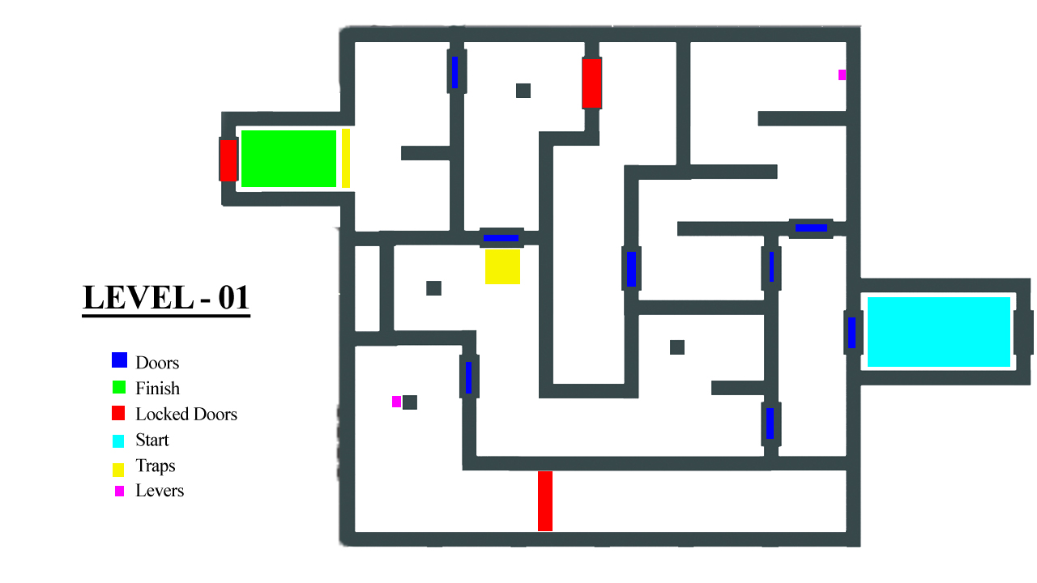**Game Design:-**

Level01:-

Level02:-

